Genome size and leaf morphology variations of Vaccinium uliginosum in Central Western Carpathians

Zuzana Vaneková¹ and Haider Sami²

1 Division of Pharmacognosy, Department of Pharmaceutical Sciences, Faculty of Life Sciences, University of Vienna, Josef-Holaubek-Platz 2, 1090 Vienna, Austria
2 Laboratory of Macromolecular Cancer Therapeutics MMCT, Department of Pharmaceutical Sciences, Faculty of Life Sciences, University of Vienna, Josef-Holaubek-Platz 2, 1090 Vienna, Austria.

Short title: Vaccinium uliginosum ploidy and morphology

Correspondence: zuzana.vanekova@univie.ac.at

Supplementary Table 1. Habitat descriptions of the sampled locations
ID | Sampling location | Predominant plant community | Ploidy | Habitat
SK1 | Suchá Hora bog | Sphagnion medii, Pino-Ledion | 4 | Peat bog with Sphagnum groundcover, thin birch and pine forest canopy, V. uliginosum mixed with Ledum palustre.
SK2 | Klin bog | Sphagnion medii | 4 | Peat bog with Sphagnum and V. oxycoccos groundcover, no canopy
SK3 | near Solisko | Loiseleurio-Vaccinion | 2 | Alpine heath covering the clearing in Pinus mugo under the ski lift
SK4 | Štrbské pleso bog | Sphagnion medii | 4 | Peat bog with Sphagnum groundcover, thinly overgrown with P. mugo and spruce
SK5 | near Skok waterfall | Loiseleurio-Vaccinion | 2 | Alpine heath above the tree line
SK6 | Uhlištiatka bog | Sphagnion medii | 4 | Peat bog with Sphagnum groundcover, overgrown with P. mugo and spruce
SK7 | Škaredý žľab | Pinion mugo | 2 | A single specimen of V. uliginosum next to a hiking path through dense P. mugo
SK8 | Prašivá | Loiseleurio-Vaccinion | 2 | Alpine heath above the tree line
SK9 | near Žiarska chata | Vaccinion myrtilli | 2 | Avalanche clearing in spruce forest, V. myrtillus and V. vitis-idaea groundcover; a single specimen of V. uliginosum in a large radius
SK10 | Jalovec pass | Loiseleurio-Vaccinion | 2 | Alpine heath above the tree line
SK11 | near Príslop | Loiseleurio-Vaccinion | 2 | Alpine heath above the tree line
SK12 | Spálená valley | Loiseleurio-Vaccinion | 2 | Alpine heath above the tree line
SK13 | Medzi bormi bog | Sphagnion medii | 4 | Peat bog with Sphagnum groundcover, thin birch and pine forest canopy, V. uliginosum mixed with Ledum palustre.
SK14 | Skalnaté pleso | Loiseleurio-Vaccinion | 2 | Alpine heath above the tree line
SK15 | near Svišťovka | Loiseleurio-Vaccinion | 2 | Alpine heath above the tree line
SK16 | Trojrohé pleso bog | Sphagnion medii | 4 | Alpine lake turned peat bog with thick Sphagnum moss layer covering the lake edges; surrounded by P. mugo overgrowth
SK17 | near Poľana | Vaccinion myrtilli | 2 | Alpine heath above the tree line
SK18 | Stredná hoľa | Vaccinion myrtilli | 2 | Alpine heath above the tree line; a single specimen of V. uliginosum in a large radius

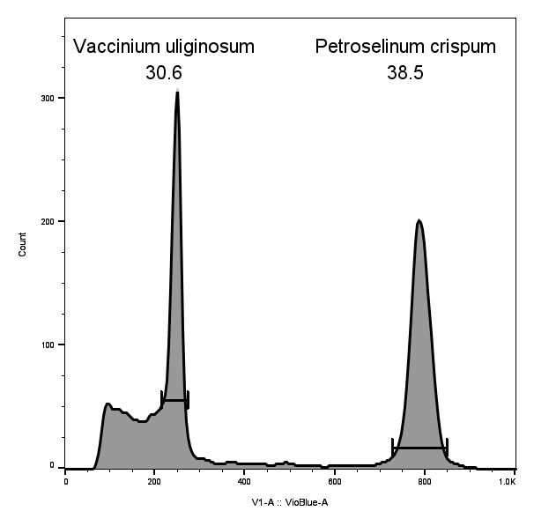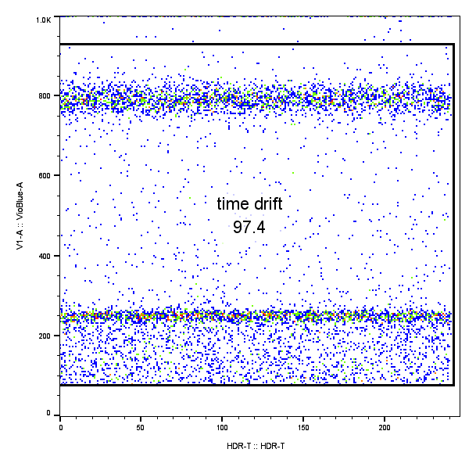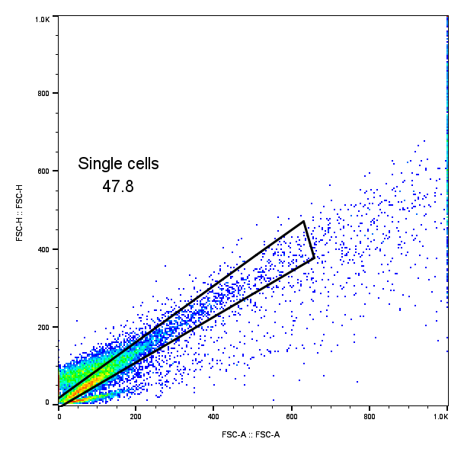
A B C
Supplementary Fig. 1. Gating strategy of a Vaccinium uliginosum L. cell nuclei sample. A indicates doublet discrimination, B excludes potential drift of fluorescence values in time (usually not present if the sample was allowed sufficient incubation time after staining), C shows the gating of G1 peaks for both internal standard (P. crispum) and analyzed plant sample. For both, CV and mean peak values are calculated.

